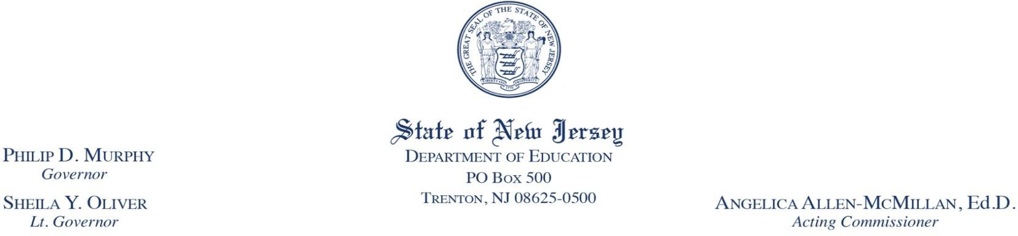

To: Superintendents, Chief School Officers, and Early Childhood Program Supervisors
From: Office of Kindergarten to Third Grade Education, Division of Early Childhood Services, NJDOE
Date: February 16, 2022
Subject: Resources for Kindergarten to Third Grade Early Childhood Education Programs – Winter 2022
Enclosed please find a packet of resources for use in your kindergarten to third grade early childhood education program. The resources are designed to help you and your team extend student learning and development beyond the classroom. The content of the resources provides early childhood educators, administrators, and families with support to use home and school learning partnerships as a tool to improve student outcomes.
Research on educators’ communication and partnership practices post-pandemic revealed that teachers, school leaders, and families saw value in the new types of partnerships focused to help young children learn. The content of home and school communications has changed so the attached resources were created to support your program’s success. Here are a few influential points from the research:
EdWeek Research Center
- More than 75 percent of educators said that parent and school communication about learning increased during the pandemic and 37 percent of them said it increased “a lot.”
- The survey found that 79 percent of teachers, school leaders, and district administrators said that the upswing in teaching and learning-based communication had a positive impact on academic outcomes with a greater focus on children’s individual learning needs.
- Communications shifted from discipline and deficits to partnership strategies that support students.
Survey by Rutgers University
- Parents' communication about their child’s learning is up among some of the most vulnerable groups of students whose parents are typically the hardest to reach.
- More than 50 percent of each hard-to-reach group, including families with incomes below the federal poverty level, say that because of the improved communications from school, they now feel more confident in helping their kids with schoolwork than they did before the pandemic.
- Sixty-two percent of parents surveyed by Rutgers said they have a better picture of their child as a learner than they did before the pandemic, including their academic strengths and weaknesses. And two-thirds reported that they have a stronger sense of what their child is learning in school and how they can provide support.
If these improvements are going to continue, we all need to commit to support home and school learning partnerships. Therefore, educators in the Office of Kindergarten to Third Grade Education created a packet of resources for your early childhood teachers, school leaders, and families.

Suggested ways to use the resources:

For Parents and Families
- Post on teacher websites.
- Send home with homework as supplemental teacher communications.
- Provide parents with direct communication and standards-based insight on what children should know and do.
- Use as teachers’ strategy to extend student learning beyond the classroom.
- Guide and build parents’ capacity to create developmentally appropriate opportunities outside of school.
- Provide information to parents so they can participate in the development of student goals.
- Distribute as resources for Parent Academies, family learning events, Math Nights, reading events, parent conferences, PTA or PTO meetings, back-to-school events, and other planned events focused on student learning.
- Use as a conversation guide at parent and teacher conferences.
- Include in new family orientation packets.

For Teachers, Academic Coaches, Supervisors, Administrators, and other Educators
- Use for PLC discussions on ways to strategically link parent engagement to student learning.
- Support for educators’ reflection on high-quality indicators for self-assessment and continual program improvement.
- Develop PD workshops on a strong P-3 approach to parent and family engagement.
- Serve as a sample for teacher-created communications about learning.

Share with after school providers and community facilities that support 2-Gen family and child needs.
- Include in transition packets as students move from one grade to the next. (Across the preschool to third grade continuum)
- Highlight learning and development indicators for families to use when speaking with their child’s teachers and pediatrician.
- Distribute at home visits.
- Include in summer packets to support student learning and minimize summer slide.
A list of the documents in the resource packet follows this memo. It is titled “Why, What, and Who Should Use the K-3 Winter Resource Packet 2022.” It includes descriptions and suggestions for use. After your review, please forward the packet and the information in this memo to your early childhood team members.

Who should receive and facilitate use of the resources?
- Early Childhood Program Supervisors
- Teachers
- Principals
- Academic Coaches
- Counselors/Social Workers/Community Parent Involvement Specialists (CPISs)
- Parents and families
- PTA or PTO members

Thank you for the time, interest, and energy you and your early childhood team invest in extending student learning beyond the classroom. We hope this packet of resources provides helpful tools to assist you with that work.
Please send questions or feedback to the Office of Kindergarten to Third Grade Education Team at K-3Office@doe.nj.gov.

